Cloud AI Bootcamp Day 2 : Part 1

1. Please go to portal.azure.com
2. Select “Create a resource”
3. Search for “Azure Search” and Select “Azure Search” and Click “Create”.
4. Enter the New Search Service information and Click Create.

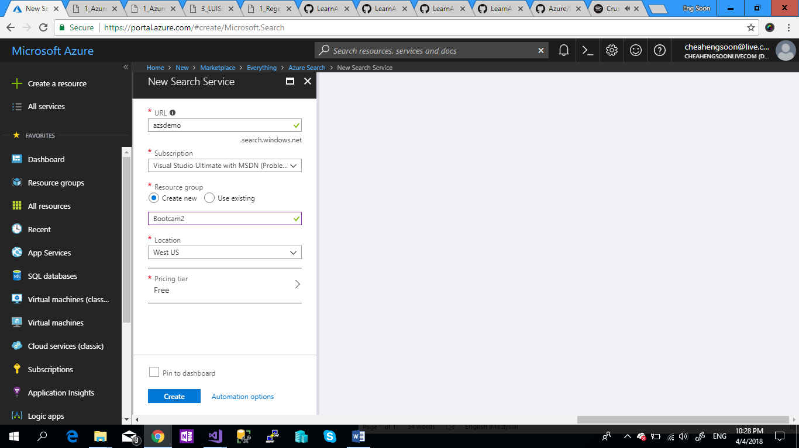

1. Select “Import data”.

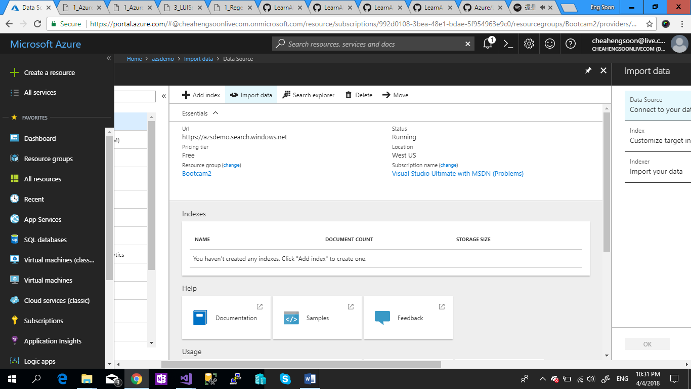

1. Select “Data Source” > Select “CosmoDB” > Enter the Information Needed > Click “OK”

For Connection String:

AccountEndpoint=https://anthobootcampdb.documents.azure.com:443/;AccountKey=XzxwNshrS92RAycyikcSNLOtrDdTMQIYsOHDLko22QDHVCNi4b3YW7pqrzhDPZJupwelnlABrqY4m3nCr686Yw==;

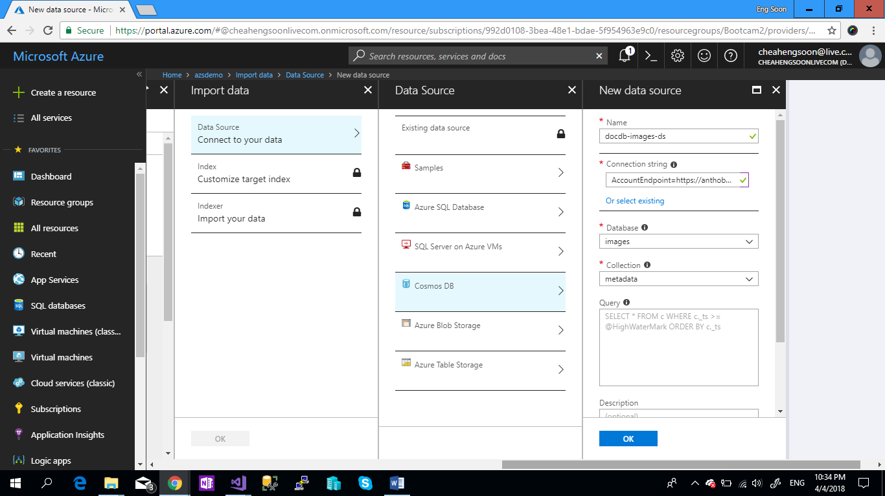

1. In the Index Section.

Index name : Images & follow with the “Basic” Tab setting And “Analyzer” setting.

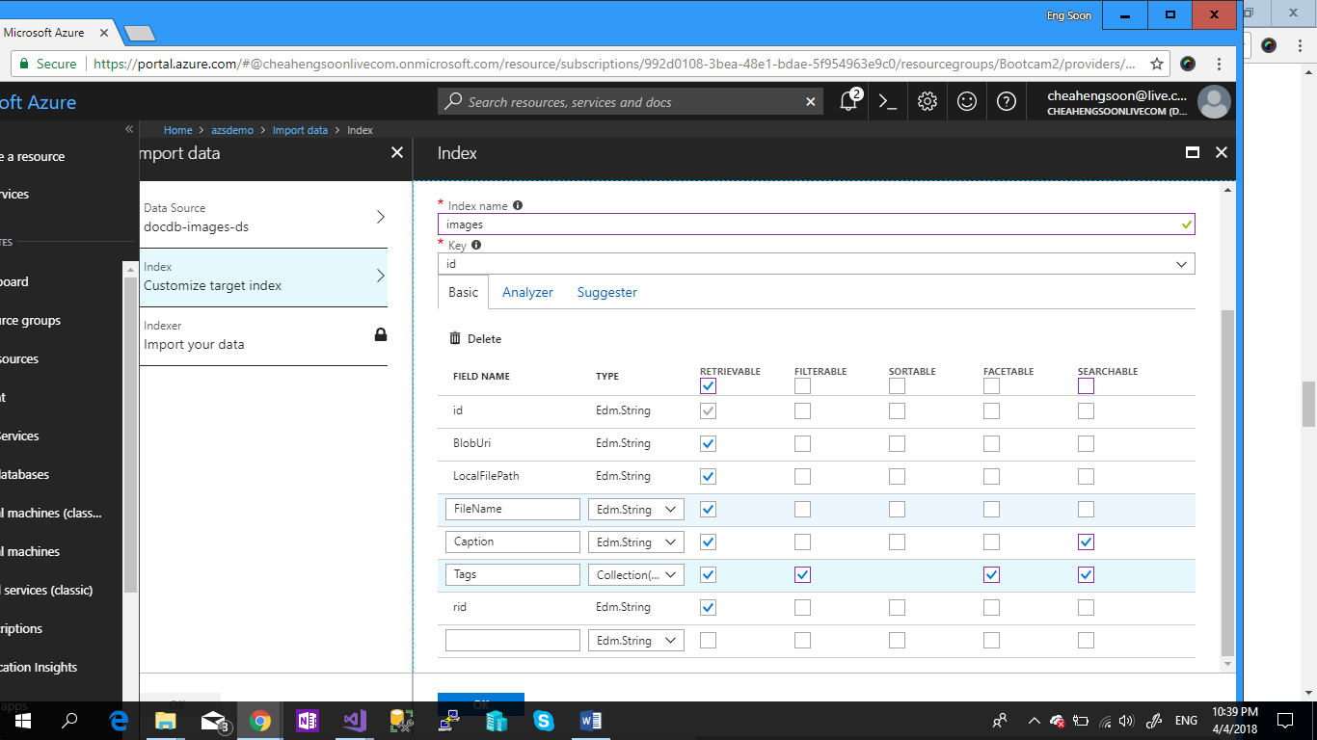

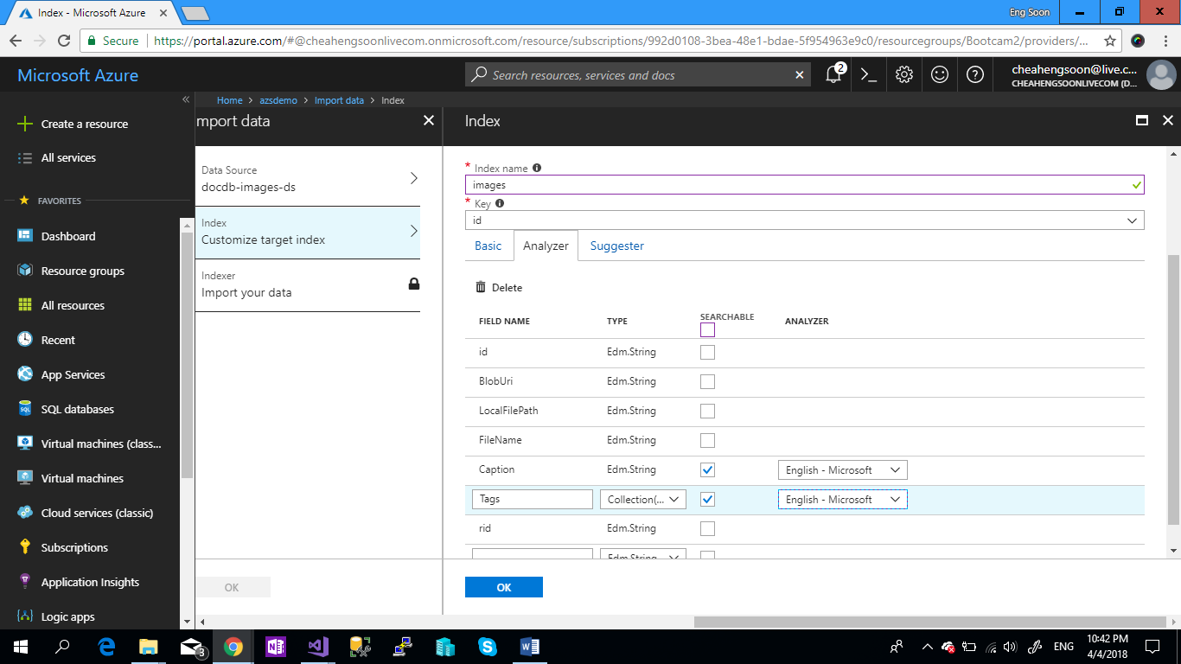

1. In the “Suggester” Tab and Click: OK

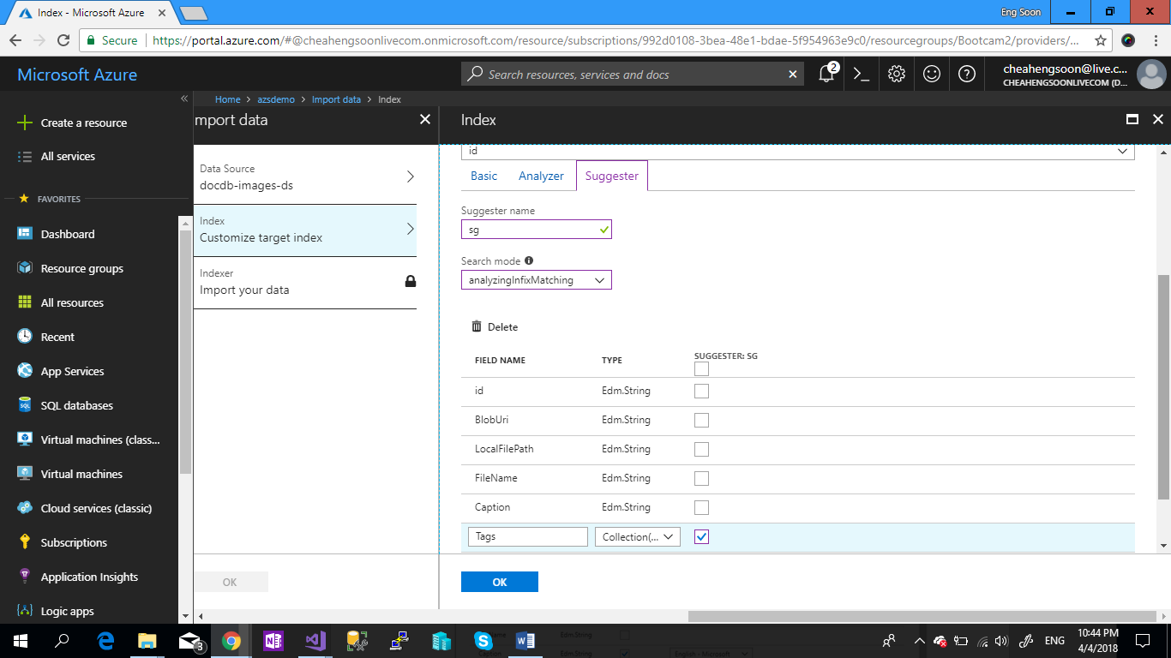

1. In the Create an Indexer, please following the settings. And click “OK”

